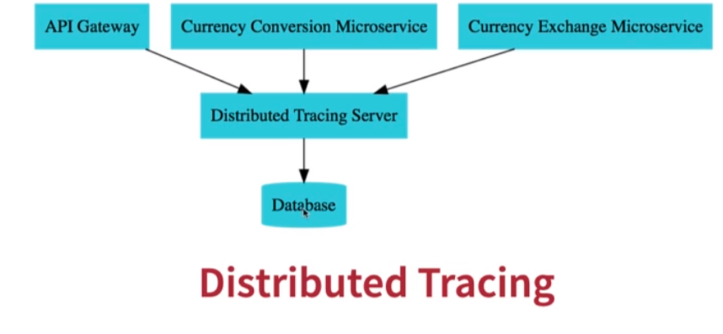

Docker page for the zipkin : https://hub.docker.com/r/openzipkin/zipkin

1. Run zipkin on local system:

> docker run -p 9411:9411 openzipkin/zipkin:latest

2. Sleuth assigns a unique id to each request.

3. Add below to currency exchange api build.gradle:

implementation 'org.springframework.cloud:spring-cloud-sleuth-zipkin'

Recommended Arch for Zipkin:

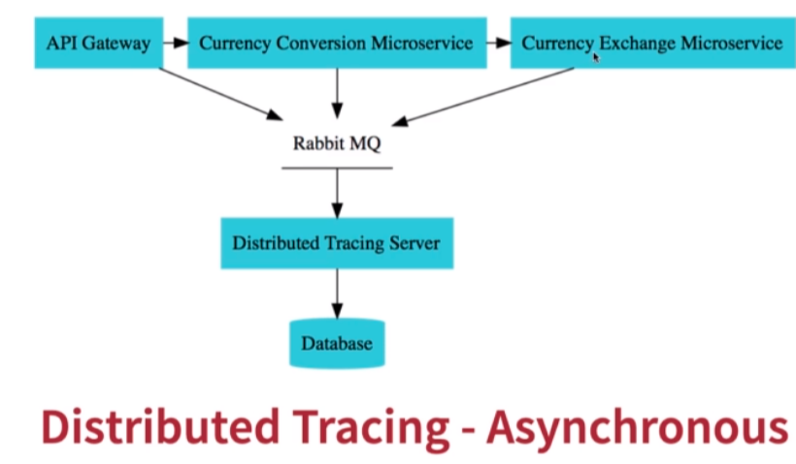
We are putting Rabbit MQ in between APIs and Tracing server since tracing server can go down.

How apis are able to find zipkin server:

spring.zipkin.baseUrl=http://localhost:9411/

